MID-Sem CP LAB assignment

**ID NO: 2020A7PS0128U**

**Name: ANURAG KUMAR JHA**

**Instructor: Dr. Nand Kumar**

**Date of Submission :- 7.11.2020**

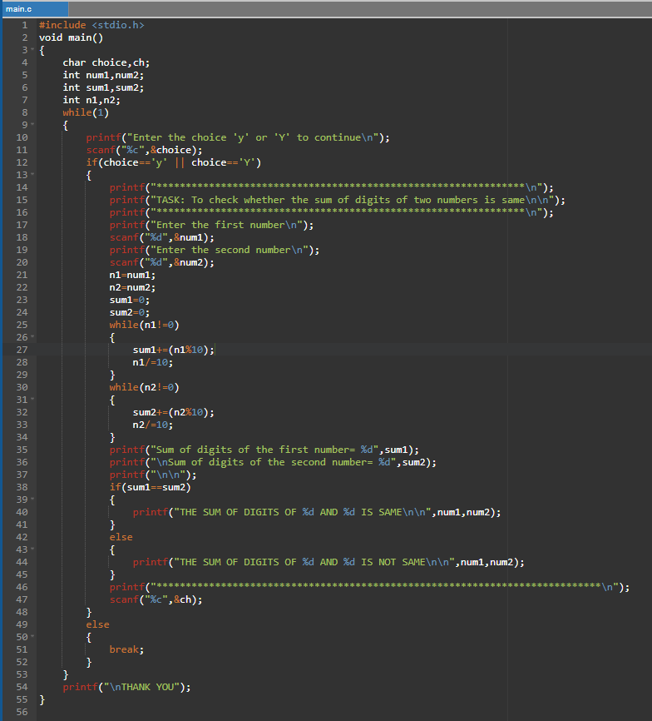

Figure . Screen Shot of the Code on the online compiler

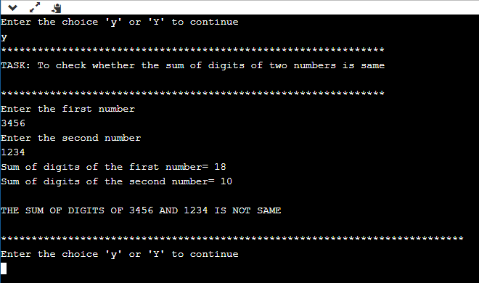

Figure . Screenshot of the output on given sample input

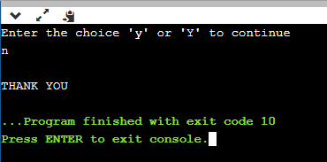

Figure .Screenshot when the input parameter is unfavorable

CODE SEGMENT :

